# LO11.1 Explain the role of sticky prices in the aggregate expenditures model

## A “stuck price” model

* Most important assumption is that prices are fixed
* Keynes had made this simplifying assumption because he had observed that prices has not declines sufficiently during the Great Depression to boost spending and maintain output and employment at their pre-Depression Levels
* Macroeconomic theories before the Great Depression
  + Predicted that prices would fall to equate quantity supplied and quantity demanded

## Unplanned Inventory Adjustments

* During the Great Depression
  + There were unplanned changes in inventory
  + Households and business unexpectedly reduced their spending, which caused inventories of unsold goods to unexpectedly surge.
  + Unable and unwilling to slash their prices, firms could not sell output fast enough to prevent inventories from continuing to pile up
  + They greatly reduced their rates of production, in some cases shutting down factories completely until inventory levels declines
  + Unemployment increased, idle resources
* Another important assumption Keynes made is that production decisions are made in response to unexpected changes in inventory

## Current Relevance

* Keynesian aggregate expenditures model remains relevant today because many prices in the modern economy are inflexible downward over relatively short periods of time

## A preview and assumptions

* The presence of excess production capacity and unemployed labor implies that an increase in aggregate expenditures will increase real output and employment without raising the price level

# LO11.2 Derive an economy’s investment schedule from the investment demand curve and an interest rate

* In the private and closed economy, the two components of aggregate expenditures are consumption, C, and gross investment, Ig.
* Planned investment is independent of the level of current disposable income or real output
* Investment schedule is NOT the same as investment demand curve
  + Investment schedule shows the amount of investment forthcoming at each level of GDP

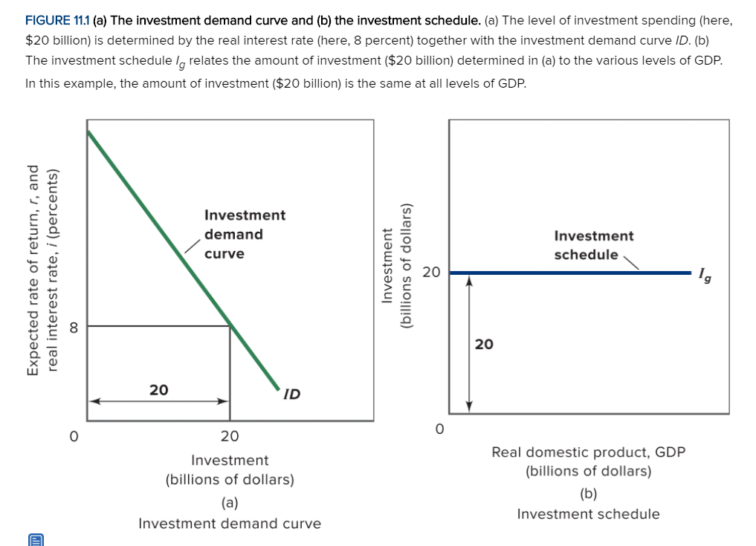

# LO11.3 Combine consumption and investment to create an aggregate expenditures schedule for a private, closed economy and determine the economy’s equilibrium level of output

* PRIVATE CLOSED ECONOMY
  + Combining consumption schedule with investment schedule of the previous schedule to explain the equilibrium levels of output, income and employment

## Tabular Analysis

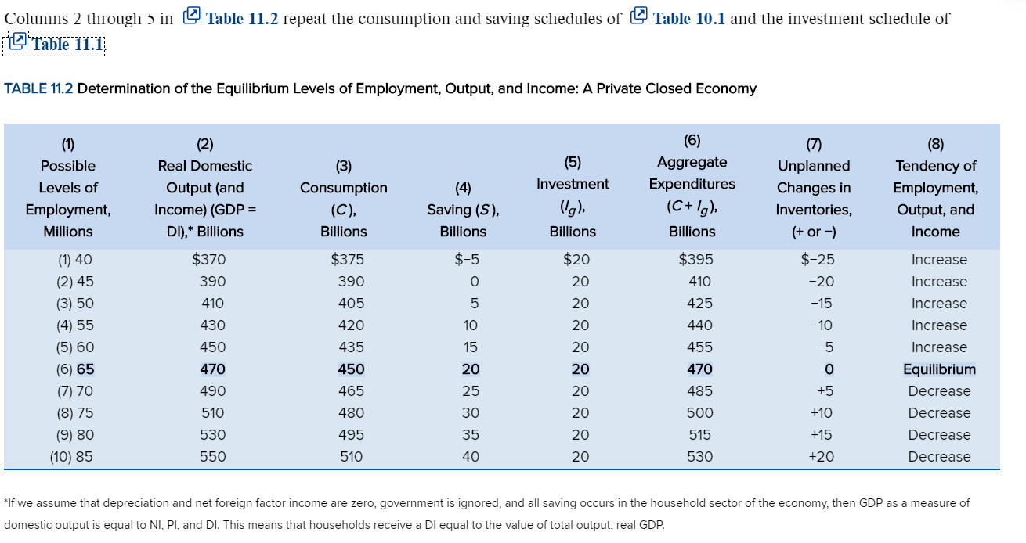

* Real Domestic Output
  + Firms are willing to produce any one of these 10 levels of output just as long as the revenue that they receive from selling any particular amount of output equals or exceeds the costs of producing it
  + Those costs are the factor payments needed to obtain the required amounts of labor, land, capital and entrepreneurship
    - Wages, rent, interest and profit
* Aggregate Expenditures
  + In the private closed economy, aggregate expenditures consist of consumption plus investment
* Equilibrium GDP
  + Equilibrium output is the output whose production creates total spending just sufficient to purchase that output
  + Total quantity of goods produced (GDP) equals the total quantity of goods purchases (C + Ig)
  + There is no overproduction which would result in excess inventories and consequently cutbacks in production
  + There is no excess spending, which would draw down inventories of goods and prompt increases in production
  + No reason for businesses to alter this rate of production
* Disequilibrium
  + No level of GDP other than the equilibrium level of GDP can be sustained
  + Column 1 to 5: spending exceeds GDP
  + Column 7 to 10: GDP exceeds spending

## Graphical Analysis

* 45-degree line 🡪 GDP = C + Ig

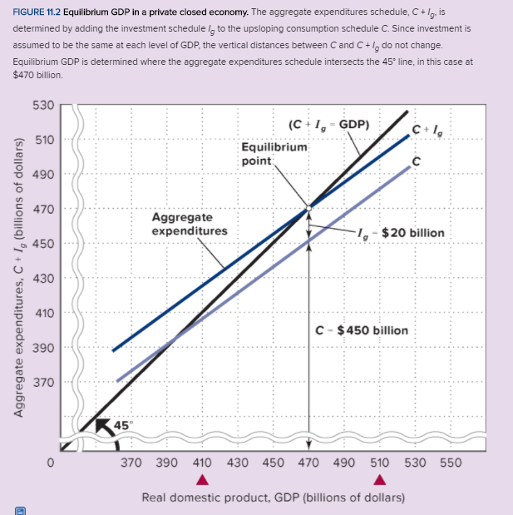

* The AE line shows:
  + Total spending rises with income and output(GDP), but not as much as income rises
    - Because MPC is less than 1
  + AE line C + Ig is parallel to the consumption line 🡪 slope is equal to MPC
* The equilibrium level of GDP occurs at the intersection of the aggregate expenditures schedule and the 45-degree line

# LO11.4 Discuss the two alternate ways to characterize the equilibrium level of real GDP in a private closed economy

* Table 11.2 reveals two more characteristics
  + Saving and planned investment are equal
  + There are no unplanned changes in inventories

## Saving Equals Planned Investment

* Saving is leakage
* Consumption take things off the shelf but not enough
* Investment also removes from the shelf
  + They sell capital to other businesses
* So savings offset investment

## No Unplanned Changes in Inventories

* As part of their investment plans, firms may decide to increase or decrease their inventories
* There are no planned changes in inventories at equilibrium GDP
* Unplanned changes can cause changes in unemployment

# LO11.5 Explain how the multiplier affects equilibrium real GDP

* An initial change in spending can cause a greater change in real output through the multiplier effect

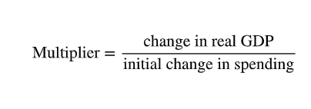 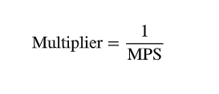

* Suppose that the expected rate of return on investment rises or that the real interest rate falls such that investment spending increases by $5 billion
* Effect in shown in upward shift

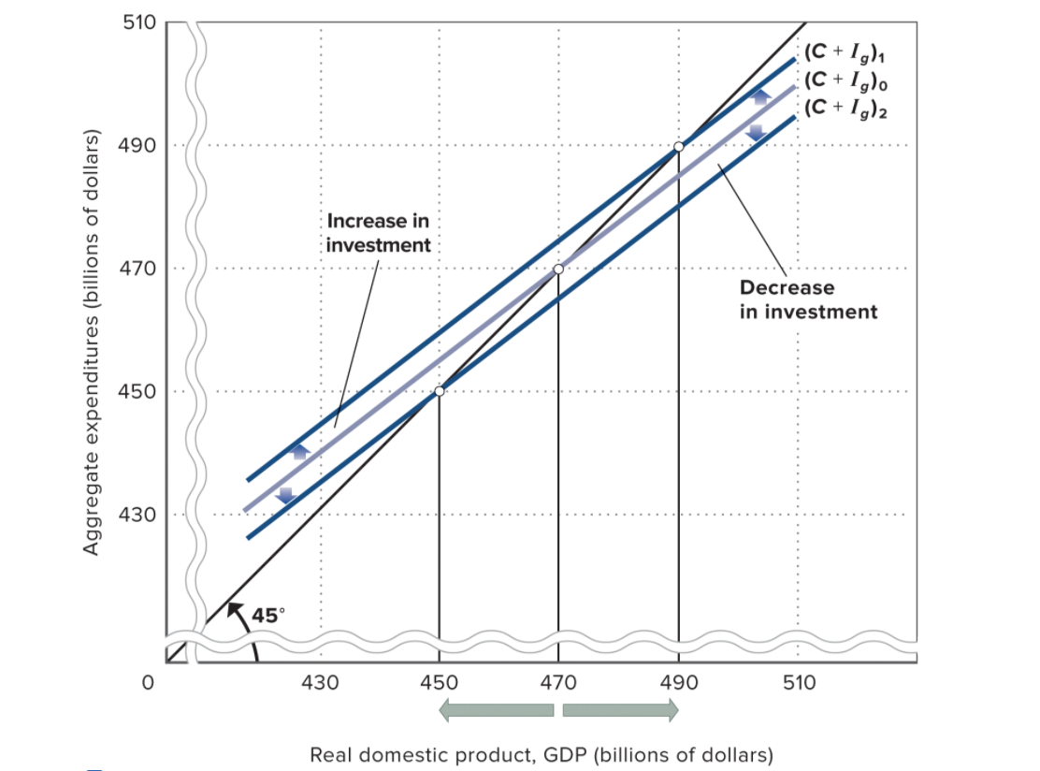

* Upward is increase
* Downward is decrease
* The extent of changes in equilibrium GDP will depend on the size of the multiplier

# LO11.6 Integrate the international sector into the aggregate expenditures model

* OPEN PRIVATE ECONOMY
  + Incorporates X and M
  + Net exports

## Net Exports and Aggregate Expenditures

* Exports create domestic production, income, and employment for a nation
* Hence exports are included in aggregate expenditure
* When an economy is open to international trade, it will spend part of its income on imports
* Subtract imports from aggregate expenditure

## The Net Export Schedule

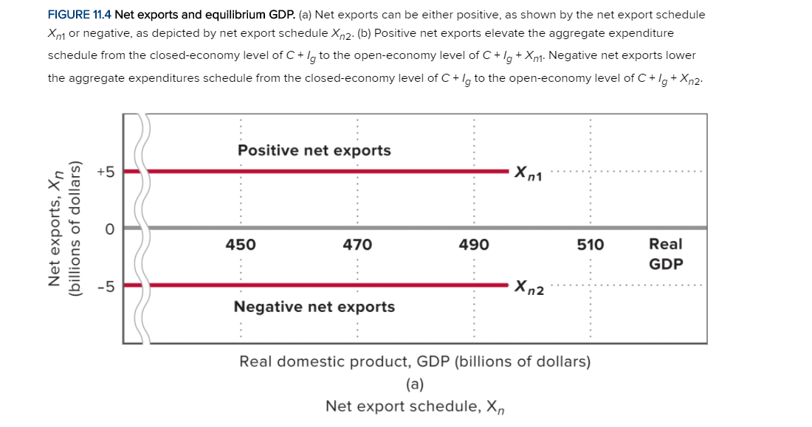

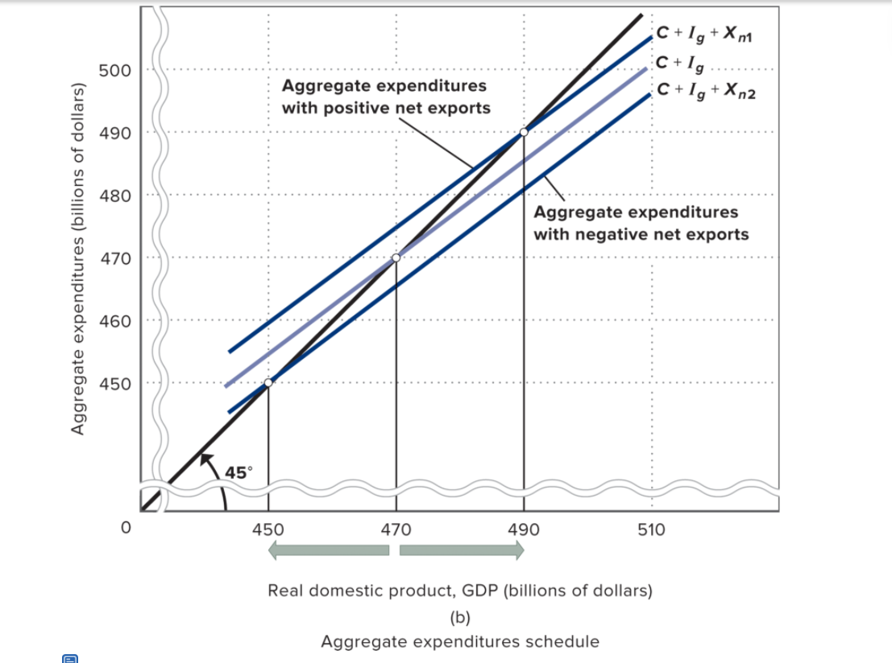

## Net Exports and Equilibrium GDP

* Wherever the Aggregate Expenditure line intersects the 45-degree line is the new equilibrium

## International Economic Linkages

* Prosperity Abroad
  + A rising level of real output and income among FOREIGN trading partners enables the country to sell more goods abroad, thus raising its net exports and increasing the country’s real GDP
* Exchange Rate
  + Depreciation
    - Exports become cheaper and imports become more expensive
    - Exports increase and imports decrease
    - Expanding nation’s GDP
* A caution on Tariffs and Devaluation
  + Trade wars are not desirable

# LO11.7 Integrate the public sector into the aggregate expenditures model

* PUBLIC OPEN ECONOMY
* Add government purchases and taxes to the model
* Assuming that government purchases are independent of GDP and do not alter the consumption and investment schedules
* Government net tax revenues are counted
  + Transfer payments
  + Personal taxes

## Government Purchases and Equilibrium GDP

* Increases in public spending, like increases in private spending, shift the aggregate expenditures schedule upward and produce a higher equilibrium GDP
* Government spending is subject to the multiplier too
* Note that increase in government spending may not necessarily be financed by increased taxes

### Graphical analysis

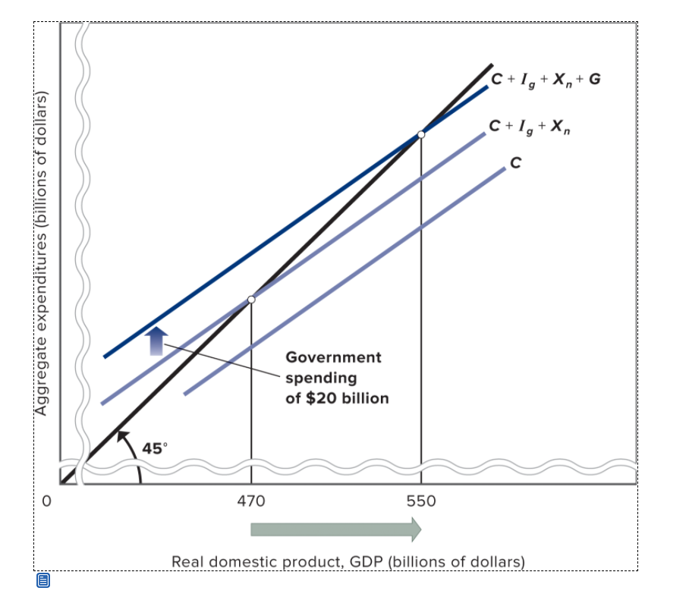

## Taxation and Equilibrium

* Government imposes taxes as well
* Lump-sum tax
  + Same amount of tax revenue at each level of GDP
* Tax lowers GDP
* By how much depends on multiplier
* Taxes reduce disposable income

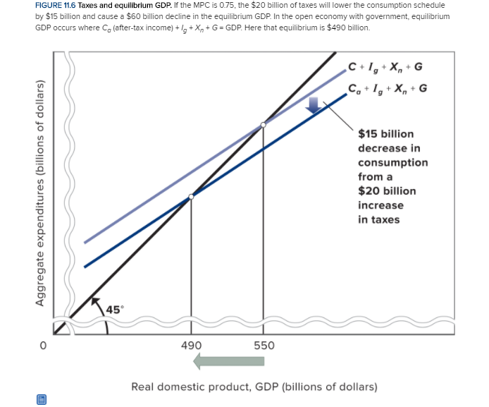

### Injections, Leakages and Unplanned Changes in Inventories

* Injections into the income-expenditures stream equal leakages from the income stream
* For the expanded economy, imports and taxes are leakages. Saving, importing, and paying taxes are all uses of income that subtract from potential consumption.
* BUT exports, government purchases and investment are injections into the income-expenditures stream.



# LO11.8 Define equilibrium GDP, full-employment GDP, recessionary expenditure gasp, and inflationary expenditure

* Equilibrium GDP need not equal the economy’s full-employment GDP

## Recessionary Expenditure Gap

* A recessionary gap is the amount by which aggregate expenditures at the full employment level of GDP fall short of the amount required to achieve full-employment level of GDP

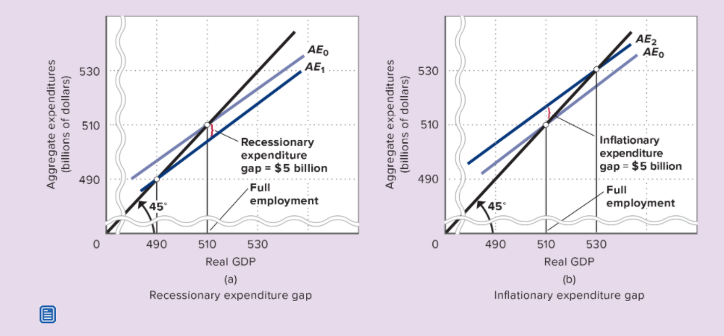

* Keynes’s solution to a recessionary expenditure gap
  + Increase government spending
  + Lower taxes
* Real-world experience that as GDP rises toward potential output, prices become increasingly flexible and inflationary in the medium run and long run
* Inflationary gap is used to describe the amount by which an economy’s aggregate expenditures at the full-employment level of GDP exceed those just necessary to achieve full-employment level of GDP
  + Will cause demand-pull inflation